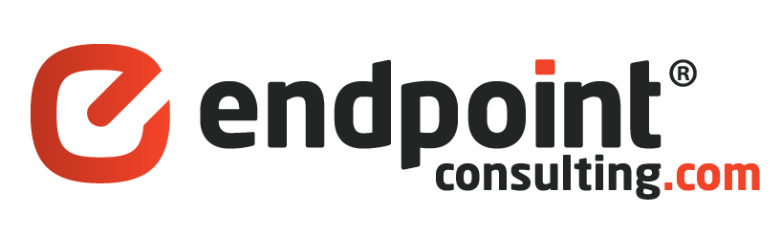Case Study

IT and Database Consulting Services for PartsBase.com

Executive Summary

PartsBase is a digital marketplace that connects buyers and sellers of aircraft components. There are presently over 115 million components for sale making PartsBase the largest source for aircraft components in the world.

PartsBase engaged EndPointConsulting (EPC) to design, deploy and maintain their database systems and web application suite.



Technologies involved:

* Microsoft SQL Server
* Microsoft .NET Framework
* HTML5
* ANGULARJS
* NODE.JS
* Web API

Challenges

PartsBase’s technology stack had not been updated for years when they first approached EPC. A total overhaul was needed, which included upgrading from SQL Server 2000, Windows 2000 & Visual Basic to newer technology. The software that was written years ago was performing poorly and needed a full re-write.

*“As the Lead Software Architect for my organization, I was at first hesitant on outsourcing and not being able to manage my developers myself. However, after speaking with Alex and his team at EPC they were able to assemble a custom team to meet my specific needs when I needed it and were able to scale down when I did not. It has allowed me to focus on bigger picture technical projects and growth while not having worry about the day to day”*

*Antonio Perez,*

*Chief Software Architect,*

*Partsbase.com*

How Services Helped

EPC provided the necessary offshore database and IT talent to help Partsbase improve their IT and Programming practices using offshore development staff at a fraction of the cost of local developers.

Results, Return on Investment and Future Plans

Currently EPC has a staff of 8 serving the needs of PartsBase including 3 full-time database administrators and 5 developers. PartsBase has increased sales and customer retention due to the improvements in processes and software from EPC. They have also successfully migrated all of their hardware infrastructure into a world – class data center based on a plan proposed by EPC.